

**Department of Computer Science & Engineering**

**Mymensingh Engineering College**

**Project Report on**

**Smart Home Exhaust System**

Course Code: CSE-3116

**Supervisor**

**Engr. Rawnak Ara Chowdhury**

MSc in CSE

Assistant Professor &Head of theDepartment

**Department of Computer Science & Engineering**

Mymensingh Engineering College

**Submitted By**

**Shakil Anowar Samrat** (Roll : 307, Reg No. : 2850)

**Izaz Uddin Mahmud** ( Roll: 308, Reg No. : 2851)

**Nuruzzaman Ashrafi** ( Roll : 333, Reg No. : 2875)

**Session: 2019-2020**

Submission Date: 09 September,2023

**Declaration**

We hereby affirm that the "Smart Home Exhaust System" project is submitted in part fulfillment of the "Microcontroller project" requirements and that it is wholly our own work, with the exception of any passages where correct attribution is made.

With best regards,

------------------------------------

**Shakil Anowar Samrat**

Roll : 307

Reg No. : 2850

**Izaz Uddin Mahmud**

Roll : 308

Reg No. : 2851

**Nuruzzaman Ashrafi**

Roll : 333

Reg No. : 2875

**Session: 2019-2020**

**Department of Computer Science & Engineering**

**Mymensingh Engineering College**

**Approval**

The project **“Smart Home Exhaust System”** is submitted by Shakil Anowar Samrat (Roll : 307, Reg No. : 2850) , Izaz Uddin Mahmud ( Roll: 308, Reg No. : 2851) , Nuruzzaman Ashrafi ( Roll : 333, Reg No. : 2875) under the supervision of Engr. Rownak Ara Chowdhury, Assistant Professor & Head of the Department of Computer Science and Engineering has been accepted as satisfactory for the partial fulfilment of the requirements for **“MICROCONTROLLER LAB”**.

**Approval Of :**

Supervisor : ………………………………..

Engr. Rawnak Ara Chowdhury

Head of the Department of Computer Science & Engineering

Mymensingh Engineering College

**Abstract**

The design and execution of a temperature-based exhaust room cooling fan system is shown in this project report. The system's goal is to keep rooms at suitable temperatures by automatically managing the operation of an exhaust fan. This is accomplished by monitoring the room temperature and operating the fan when it surpasses a predefined threshold. The study describes the system's components, operation, and practical uses, making it a simple and effective solution for temperature adjustment in a variety of situations.

**Contents**

**Introduction**

1.1 Introduction

1.2 Background Studies

1.3 Objectives

1.4 Developing the system

**Implementation**

2.1 Introduction

2.2 Hardwares Used

2.3 Circuit diagram & Connections

2.4 Code

2.5 Working of the Circuit

**Result & Discussion**

3.1 Introduction

3.2 Experimental Output

3.3 Limitations of this project

3.4 Future Scopes

3.5 Applications

3.6 Conclusion

**Chapter : 1**

**1.1 Introduction**

In an era marked by rapid technological advancements and a growing emphasis on energy efficiency, comfort, and convenience, the concept of a "Smart Home" has emerged as a transformative force in modern living. This project report introduces a pioneering system - the "Smart Home Exhaust System" - meticulously designed to augment energy efficiency, indoor air quality, and user experience within contemporary households.

**1.2 Background Studies**

**Evolution of Home Ventilation**

Over the years, home ventilation systems have undergone a series of transformations. From basic window openings to manually operated exhaust fans, these systems have played a pivotal role in ensuring adequate air circulation and preventing moisture buildup and indoor air pollution.

**Challenges and Opportunities**

However, traditional exhaust systems often fall short of achieving optimal energy efficiency and user-friendliness. They frequently operate continuously or rely on manual control, resulting in excessive energy consumption and inconsistent indoor air quality. The "Smart Home Exhaust System" seeks to address these limitations and capitalize on emerging smart home technologies to provide an intelligent and responsive solution for modern households.

**1.3 Objectives**

Primary Objectives

The "Smart Home Exhaust System" project is underpinned by a set of well-defined objectives, including:

* **Enhanced Energy Efficiency**: Develop a system that leverages real-time data to optimize the operation of exhaust fans, thereby minimizing energy consumption and reducing utility costs.
* **Improved Indoor Air Quality:** Ensure efficient ventilation to maintain a healthy and comfortable living environment by automatically adjusting ventilation rates based on indoor air quality parameters.
* **User-Friendly Interface:** Create an intuitive and accessible user interface, enabling homeowners to easily control and monitor the exhaust system through smartphones, tablets, or other smart devices.
* **Integration with Smart Home Ecosystem:** Seamlessly integrate the "Smart Home Exhaust System" with existing smart home technologies, such as voice assistants, home automation platforms, and energy management systems, to enhance the overall smart home experience.

**Secondary Objectives**

In addition to the primary objectives, this project also aims to:

* Investigate and implement energy-efficient motor control mechanisms for exhaust fans.
* Develop a robust sensor array to monitor indoor air quality, temperature, and humidity.
* Establish a secure and reliable communication protocol for remote system access.
* Conduct comprehensive testing and validation of the system's performance in real-world scenarios.

These objectives collectively serve as guiding principles throughout the project, setting the stage for a holistic and impactful solution.

**1.4 Developing the System**

The development of the "Smart Home Exhaust System" is a multi-faceted endeavor that involves a structured approach encompassing design, implementation, and rigorous testing. This report will provide in-depth insights into the development process, encompassing:

* **Technological Choices:** Detailed explanations of the hardware and software components selected for the system, justifying their suitability for the project's objectives.
* **System Architecture:** An overview of the system's architecture, including the integration of sensors, actuators, and the user interface, ensuring a comprehensive understanding of its functionality.
* **Methodologies:** A description of the methodologies and algorithms employed to achieve the project's primary objectives, such as intelligent ventilation control and user interaction design.
* **Testing and Validation:** Comprehensive testing protocols and real-world scenarios used to validate the system's performance, reliability, and energy efficiency.

This comprehensive approach to developing the "Smart Home Exhaust System" underscores the commitment to producing a solution that not only addresses current challenges but also aligns with the evolving needs of smart homeowners.

**Chapter 2**

**2.1 Introduction**

Implementation is the process of building the suggested system according to the defined design. We will discuss the system's implementation and the steps we took in this section of the report.

In this section, we have covered how to use an Arduino and an LM35 temperature sensor to construct temperature-based fan speed control and monitoring systems. The LCD makes the system user-friendly, and the microprocessor dynamically and quickly changes the speed of an electric fan in accordance with the requirements. The LCD panel concurrently displays the sensed temperature in Celsius and the fan speed in percentage.

**We used the following hardware:**

| **S.N.** | **Components Name** |
| --- | --- |
| 1 | Arduino UNO Board |
| 2 | LM35 Temperature Sensor |
| 3 | 12V DC Fan |
| 4 | 16x2 LCD Display |
| 6 | Transistor 2N2222 |
| 7 | Resistor 1K |
| 8 | Diode 1N4007 |
| 9 | Capacitor 10uF |
| 10 | LED 5mm Any colour |
| 11 | 12V Power Supply/Adapter |
| 12 | Connecting Wires |
| 13 | Breadboard |

**2.2 Hardwares used**

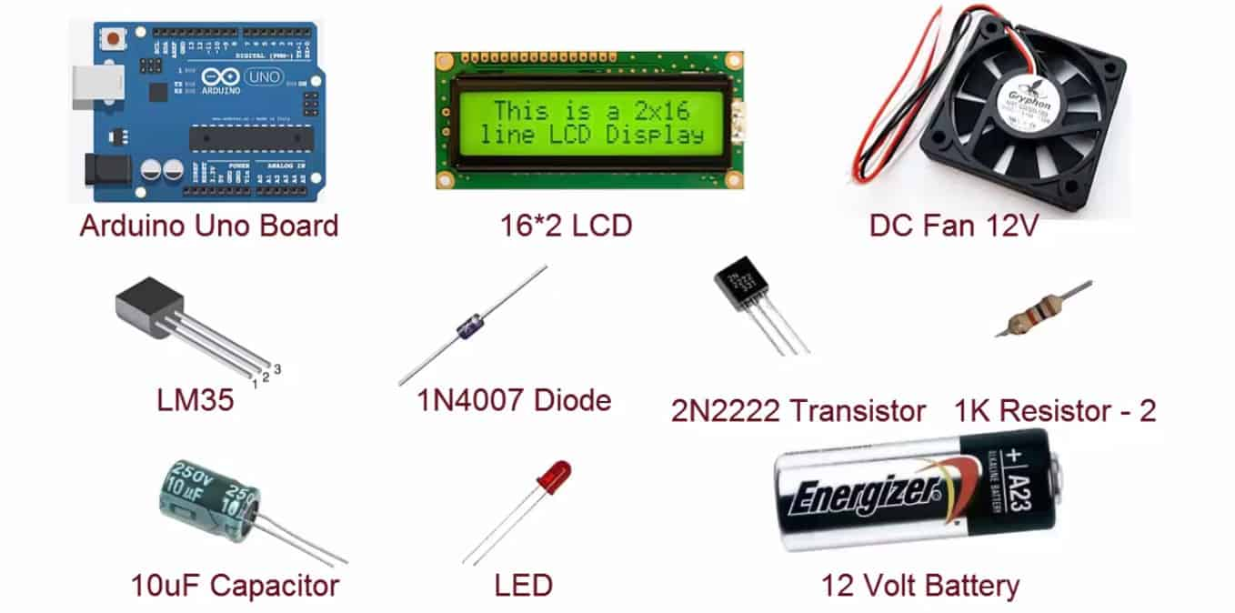

**2.3 Circuit Diagram & Connections**

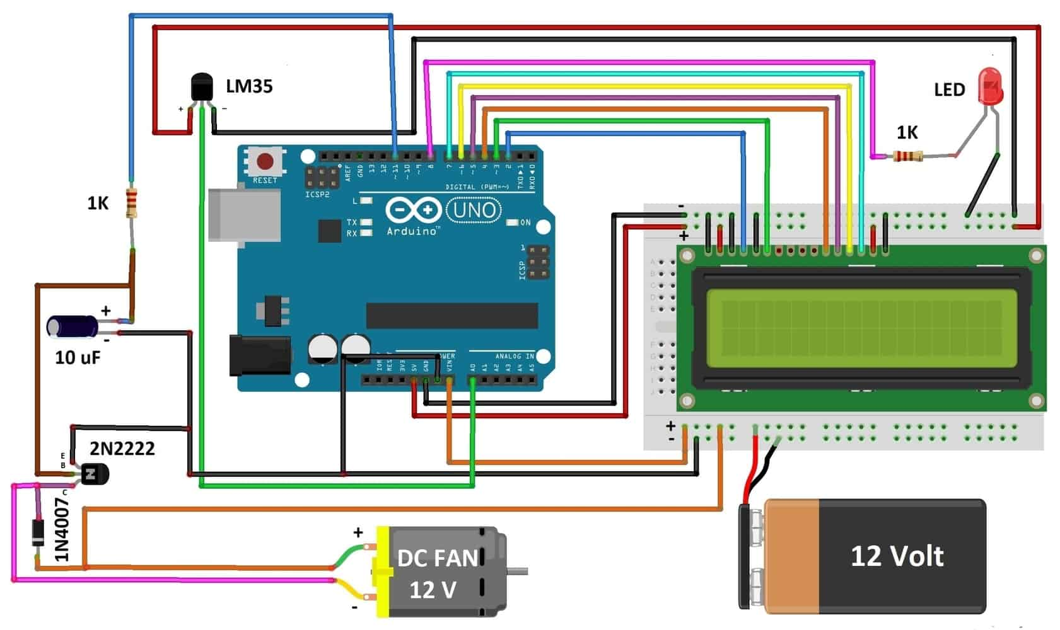

**2.4 Code**

We use Arduino IDE for Developing the Code.

Here the code is given below:

|  |  |
| --- | --- |
| 1  2  3  4  5  6  7  8  9  10  11  12  13  14  15  16  17  18  19  20  21  22  23  24  25  26  27  28  29  30  31  32  33  34  35  36  37  38  39  40  41  42  43  44  45  46  47  48  49  50  51  52  53  54  55  56  57  58  59  60  61  62 | #include <LiquidCrystal.h>  LiquidCrystal lcd(2,3,4,5,6,7);  int tempPin = A0; // the output pin of LM35  int fan = 11; // the pin where fan is  int led = 8; // led pin  int temp;  int tempMin = 30; // the temperature to start the fan 0%  int tempMax = 60; // the maximum temperature when fan is at 100%  int fanSpeed;  int fanLCD;    void setup() {  pinMode(fan, OUTPUT);  pinMode(led, OUTPUT);  pinMode(tempPin, INPUT);  lcd.begin(16,2);  Serial.begin(9600);  }    void loop()  {  temp = readTemp(); // get the temperature  Serial.print( temp );  if(temp < tempMin) // if temp is lower than minimum temp  {  fanSpeed = 0; // fan is not spinning  analogWrite(fan, fanSpeed);  fanLCD=0;  digitalWrite(fan, LOW);  }  if((temp >= tempMin) && (temp <= tempMax)) // if temperature is higher than minimum temp  {  fanSpeed = temp;//map(temp, tempMin, tempMax, 0, 100); // the actual speed of fan//map(temp, tempMin, tempMax, 32, 255);  fanSpeed=1.5*fanSpeed;  fanLCD = map(temp, tempMin, tempMax, 0, 100); // speed of fan to display on LCD100  analogWrite(fan, fanSpeed); // spin the fan at the fanSpeed speed  }    if(temp > tempMax) // if temp is higher than tempMax  {  digitalWrite(led, HIGH); // turn on led  }  else // else turn of led  {  digitalWrite(led, LOW);  }    lcd.print("TEMP: ");  lcd.print(temp); // display the temperature  lcd.print("C ");  lcd.setCursor(0,1); // move cursor to next line  lcd.print("FAN SP: ");  lcd.print(fanLCD); // display the fan speed  lcd.print("%");  delay(200);  lcd.clear();  }    int readTemp() { // get the temperature and convert it to celsius  temp = analogRead(tempPin);  return temp * 0.48828125; } |

**2.5 Working of the circuit**

Temperature sensor LM35 senses the temperature and converts it into an electrical (analog) signal, which is applied to the ATmega328 microcontroller of the Arduino UNO Board. The analog value is converted into a digital value. Thus the sensed values of the temperature and speed of the fan are displayed on the LCD. When the temperature exceeds 30°C the fan starts rotating.

An inexpensive, single, small pass transistor-like 2N222 is used here. It is efficient because the pass transistor is used as a switch.

**Chapter 3**

**Result and Discussion**

**3.1 Introduction**

In this microcontroller project, our objective was to create a Smart Home Exhaust System that works automatically. We have accomplished our goal by working hard and carefully to realize our vision. The faultless execution of every component, including lighting and fan control, in response to directions from the temperature sensor signifies the resounding accomplishment of our objective.

**3.2 Experimental Output**

After Implementing Circuit, it works properly just as we expected it to operate.

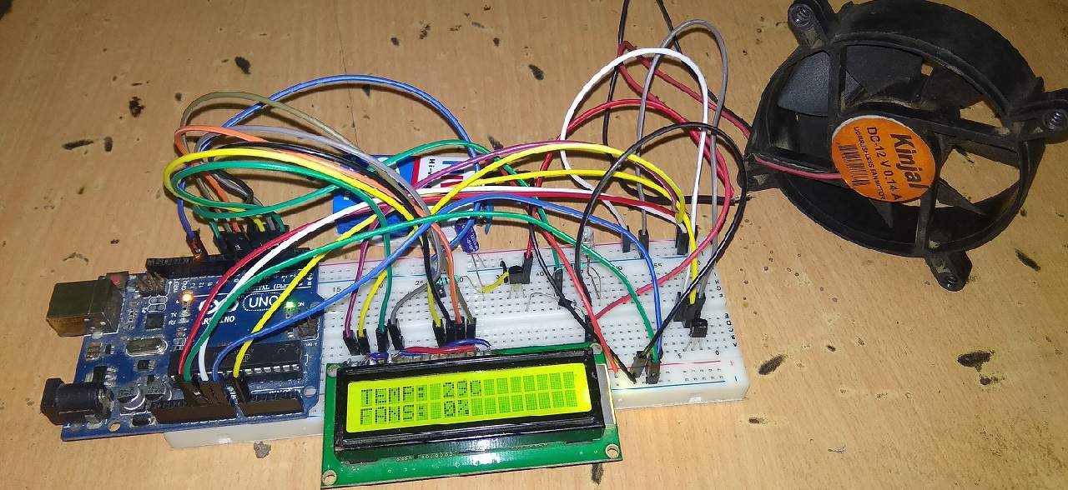

Here in the first picture of the Output is shows the TEMPERATURE is 29 degree Celcius, hence the fan is off and shows the fan speed at 0%.

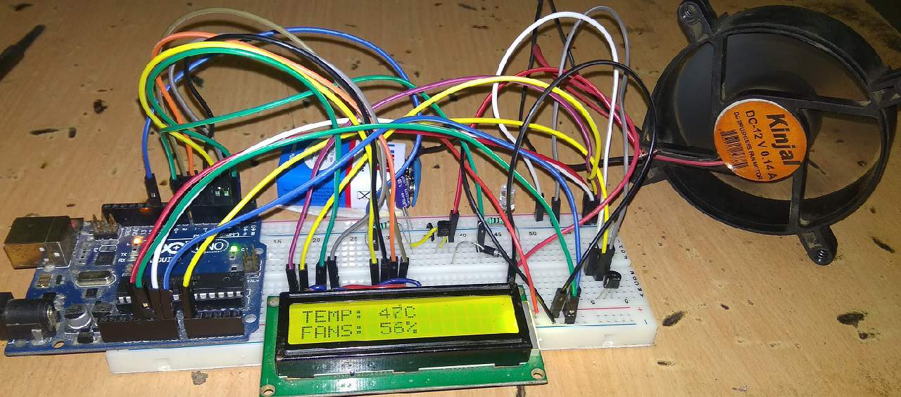

Here in the second picture it shows the TEMPERATURE has risen to 47 degree Celcius and hence, the fan started rotating while in accordance to the temperature the fan speed has also increased to 56% . This proves the working of our circuit perfectly.

**3.3 Limitations of this project**

The use of an Arduino Uno to operate fans in a SMART HOME EXHAUST SYSTEM is a fantastic idea, but it has several drawbacks and difficulties. The following are some restrictions someone might run into:

1. Compatibility: The system requires DC current to operate. It is not for controlling the AC fans which leads to our main limitation. Though by using a relay module this problem can be solved.

2. Power Consumption: The System runs on DC battery power. Running it continuously to control fan may lead to high power consumption, which could result in frequent battery replacements or the need for an external power source.

3. Scalability: The Arduino Uno has a limited number of I/O pins and processing power. If we want to control multiple appliances or add more features to our project, we may run out of resources on the Uno.

4. User Interface: The control interface for our project might be limited to a simple LED display or computer program. This can be inconvenient for users who prefer physical buttons or switches.

6. Maintenance: Like all electronic projects, our system will require maintenance over time. Components may fail or connections may become loose, requiring troubleshooting and repairs.

**3.4 Future Scopes**

Suggest possible future enhancements to the project, such as:

- Implement an IoT version of it.

- Using Relay to control the AC fans too.

- Controlling the fan with an Blynk Application

- Implementing IOT connectivity for remote control from anywhere

**3.5 Applications**

The applications areas of this project are:

1. Room exhaust system
2. Air-conditioner
3. Water-heaters
4. Snow-melter
5. Ovens
6. Heat-exchanger
7. Mixers
8. Furnaces
9. Incubators
10. Thermal baths, and
11. Veterinary operating tables.

**3.6 Conclusion**

We learn about microcontrollers and how to build something similar for a smart home exhaust control system from the engineering project. The logic and coding of the project first seemed a bit difficult, but everything worked out because of our labor. Overall, the initiative was a success. The Arduino Uno and Display module performed as expected, and we are quite happy with the project's outcomes. Although the project's functionality is rather simple, it is also quite engaging and impressive.